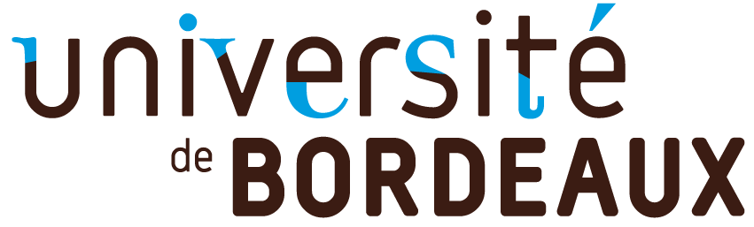

Open call
Quantum Matter Bordeaux

deadline 31 / 08 / 2020

Application to be sent to:
quantum-matter.bureau@diff.u-bordeaux.fr
Project acronym
Project title
Requested budget (€)
Principal Investigator(s)
Name of the lab(s)
Date & signature
of the P.I.(s)

1. Presentation of the call

This call is open to all projects related to Quantum Matter, especially for (but not limited to) projects:
-- nucleating new collaborations,
-- or involving different labs on campus,
-- or from scientists from other fields applying their expertise to Quantum Matter,
-- or exploring new and attractive directions of research currently absent in Bordeaux.
Outreach scientific activities will also be considered by the evaluation committee.
The typical budget per proposal is expected to be around 5 000 - 10 000 €.

The allocated funds will have to be used in 2020 and will be subject to the regulations of the University of Bordeaux. These regulations might change due in particular to the evolution of the sanitary rules.

Please send your application in pdf format using the present form, filled in English or in French, before August 31st, 2020 to quantum-matter.bureau@diff.u-bordeaux.fr

2. Project description (2 pages Maximum)

Please describe briefly the state-of-the-art in the field, the scientific motivation of this project, the expected outcomes and how the project fits within the present call. Please justify the required budget.

3. Institutes and researchers

Institutes / Teams | Researchers involved in the project

4. Budget

Expenditures | Amount (€)
Total (€)

5. Co-funding

Sources | Status: accepted / pending | Years | Amount (€)

Please explain briefly how the present application fits within the other (potential) sources of fundings.

